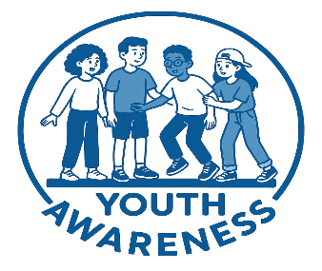STEP BY STEP GUIDE – YOUTH AWARENESS DAY 16TH OCTOBER

- Register interest by emailing youthawarenessday@gmail.com giving school name and contact detail.
- Play to students the video Presentation (one for primary schoolchildren and one for secondary respectively) see Google Drive File
- Secondary schools play and circulate amongst students and on social media this video -https://vimeo.com/1114291968/b985f2aeeb?ts=0&share=copy .
- Send to parents the High Sheriff letter (PDF in Google Drive link below).
- Please post Posters PDF in Google Drive file– Note there is one designed for primary schools. Printed posters are available if requested.
- Plan an extra fundraising activity if you can.
- Encourage students to wear blue on 16th October and donate what they can afford.
- Keep us posted on social media of all activities being planned – send photos of the young wearing blue on the day
- Please pay any funds raised to the specially created and permanent youth fund being managed by the Shropshire Community Foundation go to www.shropshirecommunityfoundation.org.uk/youth-awareness-day/ or pay into the Just Giving account https://www.justgiving.com/page/youth-awareness-day. Please note payments direct to the Foundation are preferred as there are no charges on taking the donation.

NOTE All Relevant Documents are Contained in this Google Drive File https://drive.google.com/drive/folders/1PegUO4RnYGULOqZ4dYEw2ZspsyUn6Mgj
If you cannot access the information or have any queries, please contact me on shropshire@highsheriffs.com

