The Construction, (Design & Management) Regulations, 2015 (CDM)
– How they affect Schools.


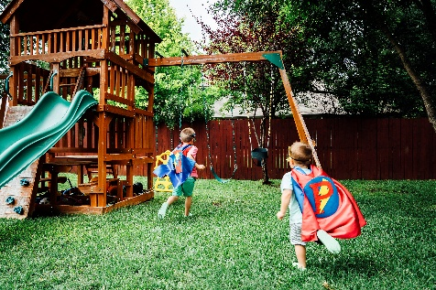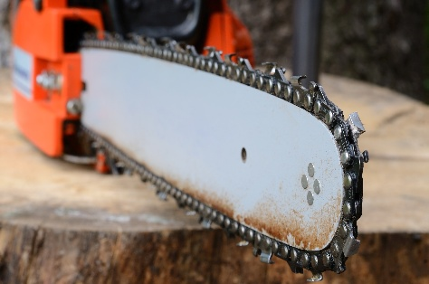

Do you directly commission any type of maintenance, improvement or construction work for your school? Am I a Client? Am I responsible?

Where schools directly procure or undertake any building, alteration or maintenance works they assume legal duties under the regulations to plan fully all health and safety
requirements associated with the work. Are you a commercial client? - HSE

Where Property Services Group (PSG) are engaged to deliver the project, they will support and advise the client in their role. It is strongly recommended that PSG are appointed to manage any construction work.

Staff in schools could be personally liable if the duties under these and other relevant regulations are not fully undertaken and completed.

When Do the Regulations Apply?
It's important to be aware that CDM applies to construction work and not just construction projects. It doesn't matter how short or small the work is, or if it involves one person, or one hundred people, if it's classed as construction work, CDM applies. The definition of construction work under CDM 2015 is far-reaching.

Even the smallest of construction works comes under the requirements of the regulations. Any work your school could undertake, from small maintenance jobs, cleaning windows, redecoration work, installation of play equipment, installation of telecommunications equipment, roof repairs, small refurbishment projects, to extensions and alterations etc.
All must comply with the requirements, although the information required must be proportionate to the hazards and risks present.

These regulations apply equally to all schools. However, schools have many different legal
forms and will need to implement the new regulations in line with their own governance and health and safety policy arrangements.

What Are You Expected to Do?
The Basics of CDM 2015 explained (Citb): https://www.youtube.com/embed/V1jLyWTscjs

The CDM Regulations 2015 requires that an organisation procuring/instructing works,
must act as client and undertake specific duties.

In every case where the school directly instructs someone to plan and undertake any form of maintenance, alteration or improvement works to your building the school should appoint a named individual to ensure that the school’s client responsibilities are suitably undertaken. The client has legal duties to perform which can be scrutinised by the HSE should an incident occur. The client should be familiar with these duties. See “Where can Schools get Help and Advice” below.

The Head Teacher carries management responsibility for the school and the HSE will expect the Head Teacher to ensure that compliance is correctly managed and as such the Head Teacher could be legally liable should there be any breaches of these duties.

The HSE has produced a checklist for clients to use in the pre-construction phase as an aid memoire, and this is produced below with some additional Shropshire Council specific advice.

Clients procuring any type of construction work without the competent advice and support of PSG should be able to meet all the standards below:

- Are you clear about your responsibilities? A short guide for clients on the Construction (Design and Management) Regulations 2015
- Have you made formal appointments, in writing, of a principal designer and principal contractor if multiple contractors are involved? Appoint them early to support planning, design, and construction safety.
- Have you verified that your designers and contractors have the necessary skills, knowledge, training, and experience? Ask for references and check professional bodies or trade associations.
- Do they have the appropriate insurance and cover level in place?
- Is the contractor registered with a ‘Safe Contractor Scheme’ such as CHAS or others?
- Is the project team adequately resourced?
- Have you shared a client brief with the project team to clarify requirements and expectations?
- Has pre-construction information about the site or structure been provided to relevant parties? (This can include: Asbestos File, Fire Evacuation Arrangements, Safeguarding arrangements, hours of work, delivery and traffic arrangements)
- Do you have access to project-specific health and safety advice?
- Are arrangements in place to manage health and safety throughout the project?
- Has a project schedule been produced?
- Has enough time been allocated for key activities?
- If required, has an online F10 notification form been submitted to HSE before work starts? HSE - F10 - Notification of Construction Project
- Is a construction phase plan prepared and fit for purpose before work begins? https://www.hse.gov.uk/pubns/cis80.pdf
- Are suitable welfare facilities arranged for workers before starting onsite?
- Is the format and content of the health and safety file agreed and ready for future use?

Failure to comply with CDM 2015 can put people at risk and compromise project standards and value. If you do not appoint the required duty holders, you will take on their responsibilities. Serious breaches may result in work stoppages, required corrective actions, or prosecution.

Don’t forget Planning Permission and Building Regulations
Building regulations apply to building works e.g. removing internal walls, change of use e.g.
changing a store to a classroom, material alterations e.g. installing windows, installation of
controlled services and fittings. e.g. replacing a boiler. They ensure structural safety, fire protection, energy efficiency, and accessibility of a building and cover the construction standards and technical aspects of the building itself.
Planning permission governs the external appearance, land use, and environmental impact of development and how it affects the neighbourhood.
You may need both, as they are separate approval processes for different considerations.

Schools (including Academies under their leases) using land or buildings that belong to the Council must ask for permission to carry out building work. When seeking permission schools can access advice on how to safely manage construction projects.

Where can Schools get Help and Advice?
- Property Services Group (PSG) 01743 251079
- Health & Safety Team 01743 25819
CDM Awareness Training available on Leap into Learning or through the H&S Team.
- HSE – Client’s Duties under CDM - https://www.hse.gov.uk/construction/areyou/commercial-client.htm

