Bouncy castles, Inflatables and events Guidance
Introduction
Kids, even big kids, love bouncy castles and inflatables, they can be great fun; however, if used inappropriately they can be dangerous and misuse can lead to serious injury or even death.
If we buy or hire an inflatable, we must ensure that we complete a suitable risk assessment and that appropriate controls are in place. Even if the equipment is brought into school and managed by a third party, we must ensure that a member of staff checks their documentation (risk assessment, equipment certification, insurance, etc) before the equipment is used and stops use of the inflatable if the equipment is not suitably anchored or appears unsafe.
What do we mean by inflatables
Inflatables are flexible air-filled structures designed for users to bounce, slide, or climb on. The fabric framework is inflated using blowers, relying on air pressure to maintain its shape. They come in a variety of designs with assorted uses, ranging from the traditional bouncy castle to slides and mazes, bungee runs, obstacle courses.
There are two main types of inflatables – constant air (continuous flow) inflatables, such as bouncy castles, inflatable slides, and sealed air inflatables such as air tracks, inflatable bounce pillows, Zorb balls etc.
Regardless of type, all can be dangerous in the wrong conditions, so need a suitable risk assessment along with robust controls to ensure they are used safely.
What are the Hazards
A number of hazards are associated with the operation and use of inflatables, including:
- Wind, e.g. by distorting or lifting and blowing the whole inflatable over
- Failure of seams or splitting of the fabric under pressure
- Air loss due to blower disconnection or failure or interruption of the power supply
- Zip failure
- Accidental injury to users caused by:
  - themselves or others, e.g. through overcrowding
  - spilling out of, or falling from, the inflatable
  - mounting and dismounting, i.e. entry or exit
  - disregard of large users for smaller users
- Tripping, e.g. over ground anchors
- Access to unguarded or inadequately protected parts of equipment, e.g. blower units
- Electrical hazards, e.g. shocks and burns
- Inadequate means of escape in the case of a fire or other emergency
- Dangerous siting of equipment
The most significant risks are those that could cause injury to the user, and escape of the inflatable due to strong winds.
You must have in place a suitable risk assessment of your own, this may reference the suppliers/operators risk assessment but should cover the main hazards associated with the safe management of inflatable play equipment.
A Model Risk Assessment is available in Appendix 2
Selecting a Suitable Supplier
When considering using an inflatable it’s important to hire it from a competent and reputable supplier. Industry trade body PIPA runs an equipment inspection scheme and authorises individuals and bodies to carry out inspections on inflatables. It also maintains a list of suppliers whose equipment has been inspected, known as the Operators List. The supplier may also use ADIPS (Amusement Device Inspection Procedures Scheme).
Anyone hiring an inflatable should use an approved operator and ensure the device being hired carries the PIPA mark. This also ensure the inflatable equipment complies with British Standard BS EN 14960 and undergoes an annual thorough inspection by a competent person.
As with any equipment, an inflatable should only be used for its intended purpose. Seek assurance from the supplier that the inflatable you hire is appropriate for your intended use.
Using and Operating Inflatables
In most cases an inflatable is hired, and the operator will usually deliver and inflate the device. They may also supply attendants whose role is to supervise users and ensure the inflatable is used and operated safely.
However, some contracts assign responsibility for supervising the inflatable to the person hiring it. In these cases, it’s vital that the operator supplies clear guidance and instruction for safe use. The school must also appoint a sufficient number of responsible people to act as attendants and provide training where necessary, further information is provided below.
Appendix 1 Inflatable Play Equipment – Safe Operation Checklist will help you ensure that you have covered the main points.
Controlling Risk Injury to Users
- Attendants
There will be a minimum number of attendants required at all times to ensure safe operation, and this may be identified by the operator or through your own risk assessment. In the event of an insufficient number of available attendants, the inflatable should be taken out of use until the requisite number are available. Entrance and exit points should always be covered by an adequate number of attendants, depending on the inflatable type.
Attendants must know and understand the rules pertaining to the safe operation of the inflatable as detailed below.
Attendants should be confident enforcing the safety rules and prevent horseplay or other inappropriate use, through constant monitoring of the activity on the inflatable. The first sign of misuse or horseplay should be corrected by use of a whistle or similar means of attracting attention.
Where responsibility has been assigned for supervising the inflatable to the school;
- The rules and procedures for safe operation must be available to the school and attendants, which will be adhered to at all times for when erecting or dismantling and using the inflatable.
- Designated school staff must receive full and sufficient training in the working of the inflatables if they’re responsible for erecting and control, including:
  - method of operation
  - safe system of work
  - safe methods of assembly and dismantling of the device
  - safe anchoring arrangements
  - safe loading of the inflatable, preventing overloading
  - control of the public including enclosures or barriers
  - associated risks and precautions
  - inspections
  - defect and breakdown procedures
  - emergency procedures
The school will need to inspect the inflatable before first use on any day. This should include:
  - crowd control measures -barriers
  - anchorage points
  - ropes and stakes
  - inspection of the material for defects
  - adequate pressure upon inflation
  - blowers
  - electrical cables & equipment – complete visual check
- If the inflatable looks misshapen or unsymmetrical, then staff MUST ensure the equipment is taken out of use.
- The inflatable should not be used until any defects, adjustments or repairs have been carried out.
- Records of all daily inspections are to be kept.
Attendants must;
- Restrict the number of users on the inflatable at the same time to the limit in the operator manual / on the unit label or your own risk assessment.
- Prevent access to users who exceed the maximum user height limit.
- Ensure boisterous or larger children are kept separate from smaller ones, and the number of users should be restricted to allow users sufficient room to play safely.
- Prevent anyone that is taller than the exterior walls while standing on the device from using it.
- Ensure that the entrance and exit remain free from obstructions.
- Ensure that users;
  - remove their footwear and any other hard, sharp, or dangerous objects
  - do not consume any food or drink, or chew gum, while using the device
  - remove glasses, where possible
  - do not bounce on the step or front apron of the device
  - do not climb or hang on the exterior walls

- Safety Barriers
With outdoor events where the inflatable is the main or only attraction and where crowds are present, a perimeter fence should be used. It should be at least 1 metre high and completely surround the device, with the exception of an access gateway. The barrier may also need an alternative means of escape in case of emergency.
The area to the front of the step or front apron should be kept clear of onlookers so that the attendant has a clear line of sight, including of the interior, and can ensure that users are able to mount and dismount the inflatable safely.
- Landing Mats
Gym mats or similar soft-landing material, with a minimum thickness of 25 mm and a maximum thickness of 125 mm, should be used to cover any hard surfaces which are adjacent to entrances, exits, and any open sides, covering an area that extends at least 1.2 metres from the inflatable. If the inflatable is indoors, mats should be made of fire-resistant material.
- Blower Location
The blower(s) should be located at least 1.2 metres away from the device.
- Controlling Risk Effects of High Winds
No inflatable should be used in winds above 24 mph (38 kmph), which is Force 5 on the Beaufort Scale (small trees in leaf begin to sway).
Certain inflatables may have a lower maximum wind speed for operation. Always check the manufacturer's operating manual to confirm the maximum wind speed for the safe operation of the inflatable.
When the inflatable is being operated outside, use an anemometer to measure the wind speed at regular intervals. If one of these is not available, the inflatable should not be operated outside. These measurements should be recorded.
Do not use smartphone weather applications to measure wind speed as they do not take localised wind conditions into account.
Adverse Weather Conditions:
You should check weather conditions for the duration of the event at which the inflatable will be used. If high winds are expected it may be necessary to stop use of the device or even deflate it. Inflatables must not be used during periods of strong or gusty winds exceeding 24 mph.
- Suitable Air Pressure of the inflatable
No inflatable should be used when internal inflation pressure is below the minimum, or above the maximum specified by the manufacturer, in the operations manual.
Regular measurements of the internal pressure of the inflatable should be taken using a suitable pressure measuring device, such as a manometer. If one of these is not available, the inflatable should not be operated. These measurements should be recorded.
- Anchoring the inflatable
It’s the operator’s responsibility to identify to what extent an inflatable requires anchoring. If they are the one to erect the device, they should ensure that a sufficient number of suitable anchor points are used – using at least 6 anchor points. Alternatively, they may supply you with information about proper anchoring.
It’s not possible to anchor inflatables with stakes when using indoors. Although there will be no risk of overturning due to high winds, it may still be necessary to secure it, to prevent ‘creep’ during use.
Ground Conditions;
It may be necessary to carry out an assessment of ground conditions where the inflatable is to be sited, to determine the suitability of anchor points. For example, more anchors may be needed for soft or sandy ground.
- Deflating the Device
Inflatable equipment should never be deflated while in use. If the blower fails, attendants should clear the structure as quickly as possible.
The inflatable should always be deflated after use to prevent people using it without supervision.

That’s a lot to think about
Yes, we agree, that’s why we insist that if you are a council maintained school, before allowing inflatable equipment to be used on site, you MUST contact the health & safety team. We can run through the main points with you and, if necessary, come out to site to give you some support.

Resources
- A generic Inflatable Amusement Devices checklist is presented in Appendix 1
- Model Risk Assessment is available in Appendix 2
Sources and Useful Links
- HSE Inflatable Play Safety Guidance
- PIPA Guidance from the Inflatable Play Inspection Scheme
For a detailed list of items and requirements for operating an inflatable, please refer to the HSE Guidance document or contact the Health & Safety team for guidance and support.

Appendix 1
Inflatable Play Equipment – Safe Operation Checklist
Location / Venue

Date

Completed by (Name & Signature)

 | Safe Operation of Inflatables Checklist | Y/N | Comments
1 | Has the equipment been sourced from a suitably competent supplier and is it appropriate for its intended use?
2 | If hiring equipment, is it from a PIPA approved operator and does the inflatable carry a PIPA mark?
3 | The owner/operator of the bouncy castle/inflatable has provided written evidence that they have the appropriate level of public liability insurance in place?
4 | Has a risk assessment of the equipment been completed by a competent person?
5 | Does the risk assessment include all aspects of storage, pre-use checks, erection, use, supervision, weather, dismantling and  inspection (by a PIPA or ADIPS approved company)?
6 | Have the hirers and attendants received suitable training in the working of the inflatable?  Is this recorded?
7 | Are clear rules and procedures available?  Does this include a before first use on any day user guide?  Are the rules and procedures adhered to?
8 | Is the inflatable inspected prior to use and thoroughly examined at least annually by a competent person?  Is this audited?
9 | Is maintenance carried out in accordance with the manufacturers guidelines and schedules?
10 | Additional comments:

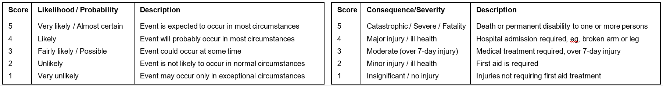
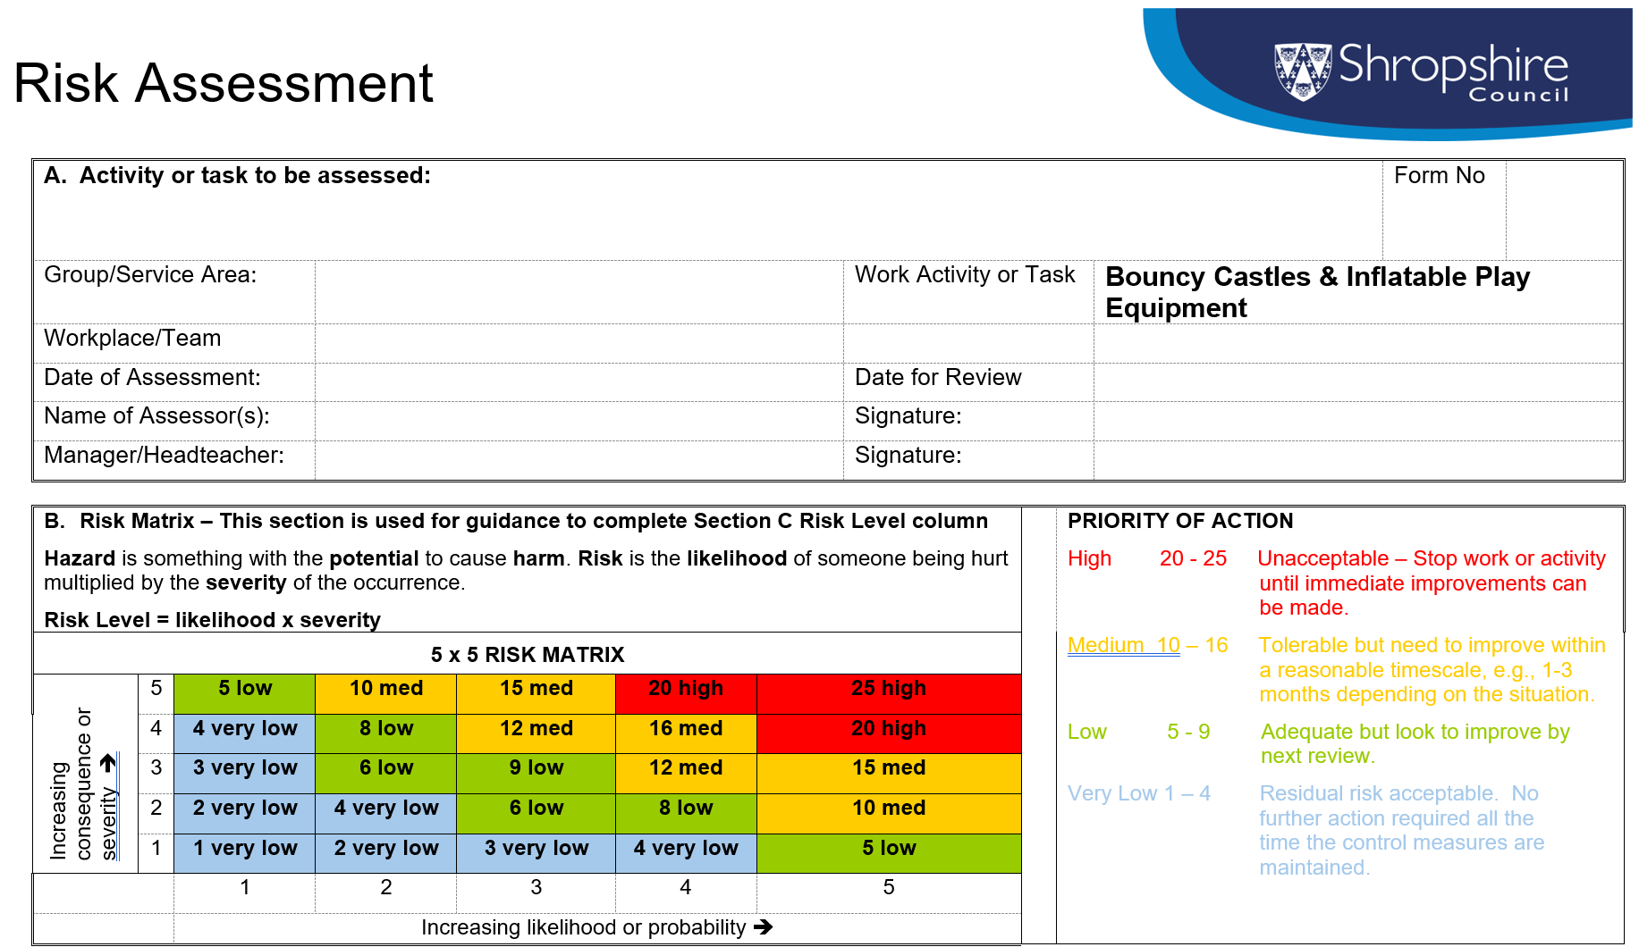
Appendix 2
- Use Section B to identify risk level for each hazard

Record any guidance referred to here (e.g. Council arrangements, Codes of Practice, HSE web pages, British Standards etc.)
………………………………………………………………………………………………………………………………………………………..

………………………………………………………………………………………………………………………………………………………..
………………………………………………………………………………………………………………………………………………………..
What are the  Hazards? |  | Who might be harmed and how | What are you already doing  (Existing Controls) | Risk  Level  Use Risk Matrix above | What further actions  are necessary | Residual  Risk  Level  Use Risk Matrix above | Action
 |  |  |  |  |  |  | Who | When
1 | Competence of supplier & safety of equipment. | Inexperienced or poorly managed suppliers may supply and erect faulty or inferior quality equipment, putting users at risk of serious harm. | Use an approved operator and ensure the device being hired carries a PIPA or ADIPS (amusement device inspection procedures scheme) inflatable play inspection certificate,  operators manual, device risk assessment and statement for operation of the facility.
2 | Insurance |  | Check owner of the bouncy castle has written evidence of appropriate PL insurance (Minimum £5 million) to cover any legal liability which they may incur e.g. defective equipment causing injury/failure to erect structure correctly.
3 | Equipment fails | Poorly maintained equipment or improper setup could put the users at serious risk of harm. | Must be thoroughly examined by a competent person every 14 months to comply with code of practice at fairs. (Blower inflatable and electrical system should be examined and a certificate issued). These should be checked before used.  Castle should be inspected prior to first use on the day in line with manufacturer’s instructions, checks should include: anchor points, anchor rope, anchor stakes, moorings, wall to tower fixings, inflatable tube, surface and seams of bed, pressure should be sufficient to give reliable firm footing, blower and electrical check.  Do not use the assembly if any defects are noted.  Evidence of the inspection must be properly recorded.
4 | Fire | All persons in the vicinity – risk of smoke inhalation and burns | A ‘powder’ extinguisher must be positioned in close proximity to the apparatus.  Apparatus must be positioned correctly.
5 | Incorrect set up resulting in malfunction or accident | Users; various injuries | Shall be positioned and set up by the hire company / providers, following their safe working methods and procedures to ensure everyone’s safety and the correct setup of the inflatable equipment;  The supplier must inflate the equipment and ensure it is anchored sufficiently with a suitable number of anchor points being used, taking into consideration of the ground conditions – more anchor points may be needed for soft or sandy ground.  Equipment must be anchored in accordance with BS EN 14960.
Inflatable equipment must be anchored in accordance with BS EN 14960

Suitable space and positioned on level grassed area.

All plant and equipment shall be positioned away from staff and students (air compressor).

Power cables shall be positioned so as not to cause a trip hazard.

6 | Anchor points becoming untethered (High winds) | The inflatable could move or tip, causing serious injury to the users on it and potentially death. | - The inflatable will not be put up if the wind exceeds 24mph.  - Wind speed is monitored throughout the day ensuring the play equipment is closed if wind speeds of 24 mph are recorded.  - Bouncy castle to be stabilised and anchored to the ground with steaks.  - The inflatable will be tethered securely to the anchor points.  - Play equipment is deflated if necessary.
7 | Appropriate safety rules being in place | Sudden deflation of the equipment, or falls from height causing serious injury | Safe system statement:  - All hard, sharp and dangerous objects e.g. footwear, buckles, glasses, pens, purses etc. should be removed prior to use.  - No bouncing at the front of the apron.  - No climbing on outside walls.  - No running from wall to wall should be allowed.  - Children of a similar size should use the apparatus at the same time (consider age group sessions etc.).  - No one taller than the height restriction should be allowed on the device.  - Age restrictions in place.  - Beginners should bounce only on their feet.  - One-one assistance may be required for children who experience difficulties with their physical control.  - No food or drink allowed on the apparatus.  - Keep users off the device during inflation/deflation.  - Perimeter fence/screen must be erected 2 metres from closed sides and 4 metres from open sides to prevent unauthorised access.  - Maximum number limits must be adhered to.
8 | Appropriate supervision and safe operation of inflatables. | Improper use will likely cause injuries to users. | Ideally the operator will provide attendants to provide supervision of the equipment and its appropriate safe use.  However if the school are taking responsibility for its safe operation, it is vital that the operator supplies clear guidance and instructions for safe use.  The school must appoint a sufficient number of attendants and provide training where necessary.
9 | Appropriate training for attendants | Inadequate knowledge or safety precautions may put the users at significant risk of harm. | Attendant must be fully trained in how to:  - Operate the device.  - Entry/exit procedure.  - Safe assembly & dismantling.  - Safety checks.  - Safe anchoring.  - Ground control measures and barriers.  - Measures to take in the event of a power failure.  - Defect reporting and accident reporting.
10 | Suitability of the equipment (bouncy castle) for the physical size and weight of the intended users | Adults are not suited for apparatus designed for smaller children – may result in falling off, sides giving way etc. | Inflatable is suitable / not suitable for adult users as confirmed with the hire company.  Appropriate controls are put in place as deemed suitable.
11 | Users colliding together – especially larger users colliding with smaller users | Smaller children especially being put at risk from impact of larger/older children or adults. | Appropriate supervision and instruction provided by the attendant to minimise the risk of collision and injury by separating and controlling access.  Attendant will ensure that users do not bump into each other or become overly boisterous.  The session will be stopped if behaviours are unacceptable.
12 | Users jumping off or falling off the front of the inflatable | Users could be seriously injured from fall from height. | Crash mats will be put down in front of the inflatable.  Supervising staff will be at the front of the inflatable at all times. They will instruct users to move back if they come to close to the front.
13 | Inflatable gets wet | Wet surfaces could cause slip hazard resulting in users injuring themselves. | - The inflatable will not be used if it rains and will be dried completely before being used.  - Food and drink will not be allowed on or near the inflatable.  - Wet ground to be covered with floor mats preventing excess water from entering the bouncy castle.  Supervising staff to stop the activity if conditions become too dangerous or hazardous.

If more hazards are identified, please add more rows
D. A Safe System of Work (SSOW) is a procedure, or set of procedures, that explains exactly how a work task should be carried out safely. It can be used to induct/train staff how to do a task. If a SSOW is needed it can be written below or in a separate document referenced below.

E. Circulation List
NAME | DESIGNATION | SIGNATURE | DATE
Pease list people who have been informed of the assessment.

