eLearning Courses

All staff requiring access must first be registered as a user on the platform arranged through the Headteacher.

To access eLearning courses on Shropshire Council's learning platform, click the link below:

Leap Into Learning
Please make sure you choose the second option when logging in with your school’s email address.

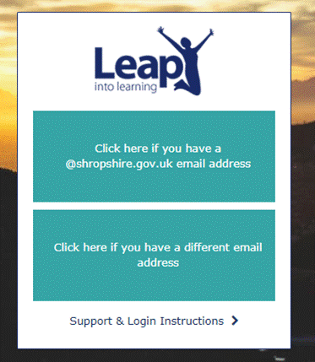
Log in with your school email address or your registered email address if different.

Your username is: email address
Your password is: Welcome1 (when you first log in)

When you log in you will be prompted to change your password.
If you have any problems, please contact leap@shropshire.gov.uk or phone 01743 254308.

