
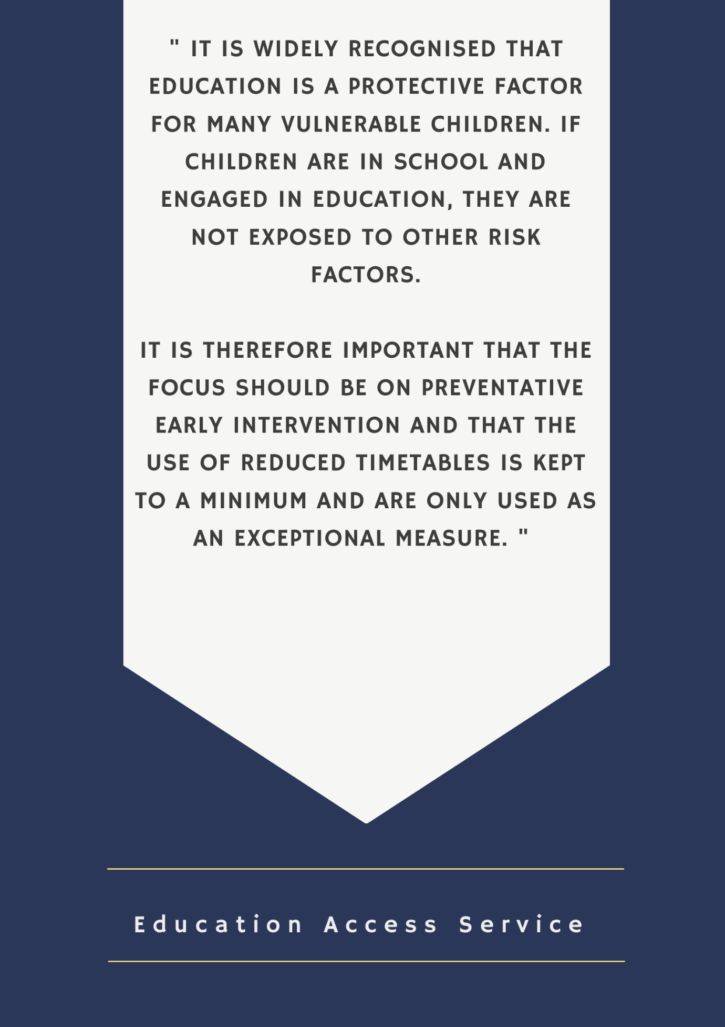
Shropshire Council has an overarching responsibility for the educational attainment and safety of all school age children in the county and schools have a duty of care towards their pupils.
LOCAL AUTHORITY POSITION STATEMENT ON THE
USE OF REDUCED TIMETABLES

It is widely recognised that education is a protective factor for many vulnerable children. If children are in school and engaged in education, they are not exposed to other risk factors.
It is therefore important that the focus should be on preventative early intervention and that the use of reduced timetables is kept to a minimum and are only used as an exceptional measure.

Local authorities are also covered by the public sector equality duty and must have regard to the need to eliminate discrimination, promote equality of opportunity and foster good relations between disabled and non-disabled children and young people.

Shropshire Council is committed to every child’s right to a full-time education and makes clear the requirement that a reduced timetable cannot be implemented without:

- An assessment of need having taken place to ensure that it will benefit the pupil.
- A risk assessment and relevant plan in place.
- Written agreement from a parent\carer.
- An interim or early annual review having been called, to which Shropshire Council’s SEND team is invited, for pupils with an EHCP.
- The presence and agreement of a representative from the Virtual School of the placing local authority at any meeting where the intervention will be discussed for a child looked after.
- A supporting Individual Healthcare Plan for pupils with medical needs.
- Schools being able to still evidence educational progress for the pupil.

The purpose of this document, therefore, is to:

- To identify a good practice approach for all maintained Shropshire schools, academies and alternative provision settings, so that reduced timetables are only used appropriately to best effect. This will protect both pupil and school.
- To assist schools in ensuring that no pupil is excluded illegally through the imposition of a reduced timetable.
- To secure a more consistent approach that restricts the use of a reduced timetable for an extended period of time, as this can impair a pupil’s progress and attainment.
- To ensure that a child’s unmet needs are identified and addressed so that they may access their entitlement to a full-time education.

SCOPE

This guidance:

- Applies to pupils of compulsory school age (who reach age 5 by 31 of August, December and 30 April in an academic year. Pupils in Y11 must remain on roll until the last Friday in June in which they attain age 16).
- Therefore, it does not apply to any agreed ‘staggered’ induction of reception-aged pupils.
- Does not apply to pupils who are dual registered with the Tuition, Medical, Behaviour Support Service (TMBSS), including Hospital Tuition, or a specialist provider of an alternative provision, as long as the pupil has a full-time offer of education.
- Does not apply to pupils on a personalised curriculum, as long as the combined learning activity means a pupil has a full-time offer of education.

DEFINITION

A timetable is considered reduced when the total hours provided are less than those provided to most of the peers of the pupil in that setting.

Education should be suitable to a child's age, ability and aptitude, considering any special educational needs they may have.

As a rule, all pupils should receive full time education consistent with their key stage:

21 hours at Key Stage 1
23.5 hours at Key Stage 2
24 hours at Key Stage 3 & Year 10
25 hours at Year 11

Source: Out of school … out of Mind? Local Government Ombudsman, September 2011.

Pupils who have a personalised curriculum are not considered to be on a reduced timetable, provided that:

- The personalised curriculum provides the pupil with full-time education provision and the school can evidence progress.
- Any provision not delivered on the school site has been approved by the school, is of an educational nature and is supervised by a person authorised by the school.
- The school has a mechanism in place for ensuring that the pupil is attending the alternative provision and should accurately record attendance.
- The school has visited the provision to ensure that there are no safeguarding risks.

STATUTORY OBLIGATIONS PLACED UPON SCHOOLS

- To provide full time education for all pupils.
- To deliver the national curriculum or, for academies, a broad and balanced curriculum.
- To provide a safe environment in which children can learn (KCSIE 2018).
- Any approach (to safeguarding and promoting the welfare of children) should be centred on taking action to ensure all children have the best outcomes (KCSIE 2018).
- To formally record all exclusions. Therefore, sending a pupil home to ‘cool off’, or refusing to allow a pupil who has not been formally excluded access to the school site, is unlawful regardless of whether these actions occur with the agreement of parents.

The Education Act 1996 states that it is the duty of parents to secure the education of their children of compulsory school age:
STATUTORY OBLIGATIONS PLACED UPON PARENTS

The parent of every child of compulsory school age shall cause him to receive efficient full-time education suitable—

- to his age, ability and aptitude, and
- to any special educational needs, he may have,

either by regular attendance at school or otherwise. Once a parent has agreed a reduced timetable for a period of 6 weeks, if the intervention at the end of this time has not delivered improvement in the child’s access to education, other strategies should be looked at because a parent could be considered to be in breach of their statutory duty at this point.

WHEN MIGHT A REDUCED TIMETABLE BE USED?

This is not an exhaustive list, but a reduced timetable may be considered a reasonable, proportionate and necessary response in the following circumstances:

- As part of a planned reintegration approach for pupils who have not attended school for a period of time due to illness, disability, mental health issues, family circumstances, post-exclusion etc.
- As part of an in-school support package. School, parent/carer and other professionals agree that a short-term (no longer than six weeks) reduced timetable would support a pupil who has become disaffected, to regain success. This should be a closely monitored intervention to address and manage the impact of significantly challenging behavioural, emotional or social needs. It is expected that this strategy would be used in conjunction with a wider intervention plan with clearly defined outcomes.
- For medical reasons when a pupil has a serious medical condition where recovery is the priority outcome. Arrangements should be part of an Individual Healthcare Plan agreed between the school and health professionals.

A reduced timetable is not seen by the DfE or OFSTED as an appropriate method of managing poor behaviour, or pupils at risk of exclusion, in the longer term. This intervention should only be considered after other strategies have been exhausted and it should only be used for the benefit of the pupil.
EXPECTATIONS OF SCHOOLS

It is expected that schools will have a range of approaches to meet need and it is important that all intervention strategies are explored, or put in place, before problems become entrenched. These interventions could be delivered in-house, commissioned or external. Collaboration with support services such as targeted Early Help, EWO, Inclusion team and EPs may be helpful in identifying ways to promote positive change and extend timetables in a timely manner. Further targeted support may be accessed/commissioned through different sources as appropriate.

A reduced timetable strategy should never be implemented without parental permission or, in the case of looked after children those with PR, because it could be construed and challenged as an unofficial exclusion, which is unlawful. The school could also be regarded as preventing the pupil from accessing the curriculum. In these circumstances the school must consider alternative interventions.

A reduced timetable should be agreed for no longer than 6 weeks.

If a pupil is normally entitled to transport assistance, the school must consider what arrangements it will make to get them to and from school. (The local authority will not provide bespoke transport arrangements in such circumstances.)

Sufficient hours and provision should be offered to enable the pupil to make academic progress, it is advised that a pupil can access at least one session each day.

Schools should exercise additional care and caution when considering reducing the timetable of *vulnerable pupils. The following examples of vulnerable pupils are not exhaustive:

- CLA (only with the agreement of the Virtual School)
- Children on the edge of care
- Pupils with EHCPs (in partnership with the SEND Team)
- Pupils with SEN
- From GRT backgrounds
- Regularly missing persons
- At risk of exclusion
- Who are offending or at risk of offending
- Whose lives have been or are affected by drugs or alcohol.

*A reduced timetable should not be implemented where there are safeguarding concerns such as a risk of Child Exploitation, a child is subject to CP planning or subject to a multi-agency strategy.

All professionals working with the pupil should be consulted when a reduced timetable is being considered and be party to informing the Risk Assessment

Pupils should be provided with differentiated work to complete at home during the period of their reduced timetable (up to six weeks). Schools should ensure that it is marked in line with the school marking and feedback policy, to reduce the impact of the temporary provision and reduced access to teachers. Please note, it is not appropriate to mark the registers using Code B.

A risk assessment should be carried out before implementation of a reduced timetable using the template included as Appendix 2.

Reduced timetables should be a response to an assessment of need so there should be an audit trail to support the proposal, which schools should be able to evidence in the Personalised Learning Plan (PLP) e.g. an Early Help Assessment, a Personal Education Plan, an Individual Behaviour Plan, Pastoral Support Plan, Individual Education Plan or Individual Healthcare Plan. The plan should include objectives for the reduced timetable that are clearly defined and understood by all parties.

Schools will retain responsibility for the academic progress of pupils on reduced timetables, therefore the lack of access to a taught curriculum will necessitate intervention to support the pupil to catch up on work missed. This should be included in the plan linked to the intervention.

CHILDREN WITH SEND

Shropshire Council has a statutory duty to provide full-time education for children with EHCPs.

If a school is considering a reduced timetable for a pupil with an EHCP the LA must be consulted and invited to an interim review or early annual review at the earliest opportunity. Any decision to implement a reduced timetable must be in consultation and agreement with the child’s parents/carers and should demonstrate a clear benefit to the child, with a carefully planned transition to a full-time timetable.

The school must make arrangements for suitable education as per the provision detailed in the EHC Plan. Schools should ensure that they are compliant with the SEND Code of Practice 2015 and the Equality Act 2010.

CHILDREN LOOKED AFTER

Shropshire Council has a statutory duty to provide full-time education for CLA.

If a school is considering a reduced timetable for a CLA pupil the Virtual School Headteacher, or a representative, and those with PR must be consulted and invited to the initial meeting and any subsequent review meetings. The Virtual School Headteacher, or a representative, will countersign the Reduced Timetable Proforma if arrangements are agreed and should be provided with a copy of the document along with the signed and completed Risk Assessment.

The Virtual School may consider arrangements for the reimbursement of a proportion of pupil premium plus funding that has been paid to the school, to enable top-up provision to be put in place.

PUPILS WITH MEDICAL CONDITIONS

Reasonable adjustments should be made to accommodate pupils who would otherwise struggle to attend school due to illness or a medical condition.
https://assets.publishing.service.gov.uk/government/uploads/system/uploads/attachment_data/file/803956/supporting-pupils-at-school-with-medical-conditions.pdf

MONITORING AND REVIEW

In cases where parents have given their agreement to the reduced timetable, the session must be marked in the register as an authorised absence using CODE C (other authorised circumstances). Parents should be made aware at the outset that the responsibility for their child rests with them during these hours.
REVIEW AND MONITORING

Schools should ensure that there is a named member of staff responsible for monitoring each reduced timetable.

Schools will notify the Education Access Service of pupils who have been placed on a reduced timetable and provide a copy of the Reduced Timetable proforma (Appendix 1).

Education Welfare Officers will discuss pupils on reduced timetables during attendance visits and will be able to provide support and advice to schools on this matter.

The EAS Manager will provide a summary of reduced timetable activity each term to the Principal Education Improvement Adviser and Director of Children’s Services. This information may be shared with the Regional Schools Commissioner and at Regional Ofsted meetings where appropriate.

The information will also be fed into the Schools’ Performance Monitoring Group, as part of the inclusion agenda and this may be a limiting factor in relation to outcomes from this group, if this protocol is not followed.

The LA will hold schools to account via the SEND Code of Practice, Exclusions and Attendance Guidance and KCSIE.

SUMMARY

- Schools have a statutory duty to provide full time education for all pupils.

- However, in the most exceptional circumstances, there may be a need for a temporary reduced timetable to meet a pupil’s individual needs.

- A reduced timetable should be in place for no longer than 6 weeks.

- The head teacher must agree a reduced timetable.

- All professionals involved should be consulted.

- The child’s parents/carers must agree a reduced timetable. Without their agreement, schools cannot proceed as this could be an unlawful exclusion.

- The LA SEND team must agree a reduced timetable for children with SEN who have an EHC Plan.

- The Virtual School of the placing authority must agree a reduced timetable for looked-after children.

- The arrangement for pupils with medical needs must follow Shropshire’s Medical Needs guidance.

- A reduced timetable should not be implemented where there are safeguarding concerns such as a risk of Child Exploitation, a child is subject to CP planning or subject to a multi-agency strategy.

- A risk assessment must be completed in every case.

- A clear action plan for improving education and addressing any identified issues for the child must be in place.

- The Education Access Service must be notified of any pupil on a reduced educational provision. Please email completed proformas to: educationaccessservice@shropshire.gov.uk

CONTACTS

Chris Kerry | Education Access  Service Manager | Christine.kerry@shropshire.gov.uk  01743 254399
Jane Parsons | Education Access & Safeguarding Officer | Jane.parsons@shropshire.gov.uk  01743 254676

Reduced Timetable Proforma
Prior to implementation, schools should undertake a risk assessment of the pupil’s needs to assess the impact that a reduced timetable would have on the pupil. It is essential that the pupil’s welfare during any absence from school is considered.

A copy of the Shropshire Reduced Timetable Protocol can be found on the SLG.

The completed Reduced Timetable Proforma should be sent via encrypted email to: educationaccessservice@shropshire.gvov.uk

Pupil Name |  | Year Group
School |  | DOB
SEN Status* |  | CLA/LAC?**
Date of last EMHP or planning meeting |  | Date of meeting with parents
*If the student has a GSP or an EHCP please liaise with the SEND Team to agree and countersign the form.
**If the student is a Child Looked After, please liaise with the Virtual School to agree and countersign the form.

Plan under which reduced timetable is proposed.  e.g., PEP, PSP, IBP, IEP, IHP |  | Plan to be attached. If not, please state why.
Reduced Timetable  Start Date |  | Reason for Reduced Timetable
Have all known professionals been consulted?

Please state teaching time per session each day, where the provision will take place and what it will. DO NOT INCLUDE LUNCHTIME HOURS.

 | AM  Start Time | AM  End Time | PM  Start Time | PM  End Time | Where will provision be delivered? | What will be delivered?
MON
TUES
WED
THURS
FRI
Total Number of supervised teaching hours per week?

Plan for increasing the in-school hours offered
Objective * | Who | By When
* The plan should have clear and measurable objectives.

Date of  2 Weekly Review |  | Final Review Date at 6 Weeks
Date of  4 Weekly Review |  | Date pupil will return to full-time provision

PRIVACY NOTICE:
- The school is collecting information about your child and the following lawful bases apply:
- Processing is necessary for compliance with a legal obligation.
- Processing is necessary for the performance of a task carried out in the public interest or for the exercise of official authority.
- A copy of our Privacy Notice, which explains how we handle personal data, can be found on the school website or requested directly from the school.
- The school may also share information to prevent, investigate, or prosecute criminal offences, or as the law otherwise allows; however, we will not share personal information unless provided for by law.
- The information provided will be held on file and may also be stored electronically.

PARENTAL AGREEMENT:
- I understand that my child will be placed on a reduced timetable between the dates specified above and I will attend review meetings and engage with any services provided to support my child.
- I am willing and able to take full responsibility for my child when he\she is not in school during school hours.
- I understand that in agreeing to this arrangement a copy of this form will be provided to the Education Access Service and to any SC professionals working with my child, along with any supporting plans.

SIGNED: _____________________________ DATE: _______________
PARENT

SIGNED: _____________________________ DATE: _______________
SCC VIRTUAL SCHOOL IF CLA/LAC

SIGNED: _____________________________ DATE: _______________
SC SEND OFFICER IF CHILD HAS AN EHCP

SCHOOL CONTACT DETAILS:
Name of person responsible for the intervention | Designation | Contact Tel. & Email Address
Headteacher Signature

Risk Assessment for Reduced Timetable

- IDENTIFICATION OF RISK (Please use a separate sheet for each risk)
Describe the concerning behaviour and risks posed:

Has this been observed or reported? |  | Who is placed at risk?
- ASSESSMENT OF RISK |  |  |  | - RISK REDUCTION
What time of the day is the risk likely to occur? |  |  |  | Proactive interventions to reduce/prevent risk  - including any staff training needs identified and/or skill teaching required for CYP
How likely is it that the risk will arise?  (Please circle) | Very likely | Likely | Unlikely
If the risk arises who is likely to be injured/hurt? |  |  |  | Early interventions to de-escalate/manage risk:  - Identify exactly what an adult will immediately do if the risk is observed.  - Identify exactly what an adult will do if the risk is reported to them by a child
Describe known triggers
What problem is the behaviour trying to solve? |  |  |  | Additional interventions to respond to situations that have escalated further  - The priority should be to ensure the safety of all concerned
In which situation does the risk usually occur?
Initial RAG rating (please circle) | Red  (Significant) | Amber  (Moderate) | Green  (Low) | Revised RAG rating  (Please circle) | Red  (Significant) | Amber  (Moderate) | Green  (Low)

REVIEW OF RISK ASSESSMENT PLAN (WK 2)  (Contributions should be sought from all affected parties,  including the voice of the child) |  |  |  |  | Date |  | Those present (names and roles)
 |  |  |  |  | .. /.. / .. |  | Those present (names and roles)
Evaluation of effectiveness or risk reduction measures set out in section 3) above
- Have the risks/behaviours reduced in frequency/intensity duration?
- What has/has not worked and why?
- Have any identified training/skills needs been met?
Proactive interventions used to reduce/prevent risk
Early interventions used to de-escalate/manage risk
Additional interventions used to respond to situations that have escalated further
Review of RAG rating (please circle) |  |  |  | Have any new behaviours/risks been identified? |  | Yes/No  (If so, the risk assessment process should be repeated) |  | Does the Risk Assessment need to continue? | Yes/No
Red  (Significant) | Amber  (Moderate) |  | Green  (Low)
Headteacher signature |  |  |  |  |  | Parent/Guardian signature
REVIEW OF RISK ASSESSMENT PLAN (WK 4)  (Contributions should be sought from all affected parties,  including the voice of the child) |  |  |  |  | Date |  | Those present (names and roles)
 |  |  |  |  | .. /.. / .. |  | Those present (names and roles)
Evaluation of effectiveness or risk reduction measures set out in section 3) above
- Have the risks/behaviours reduced in frequency/intensity duration?
- What has/has not worked and why?
- Have any identified training/skills needs been met?
Proactive interventions used to reduce/prevent risk
Early interventions used to de-escalate/manage risk
Additional interventions used to respond to situations that have escalated further
Review of RAG rating (please circle) |  |  |  | Have any new behaviours/risks been identified? |  | Yes/No  (If so, the risk assessment process should be repeated) |  | Does the Risk Assessment need to continue? | Yes/No
Red  (Significant) | Amber  (Moderate) |  | Green  (Low)
Headteacher signature |  |  |  |  |  | Parent/Guardian signature
REVIEW OF RISK ASSESSMENT PLAN (WK 6)  (Contributions should be sought from all affected parties,  including the voice of the child) |  |  |  |  | Date |  | Those present (names and roles)
 |  |  |  |  | .. /.. / .. |  | Those present (names and roles)
Evaluation of effectiveness or risk reduction measures set out in section 3) above
- Have the risks/behaviours reduced in frequency/intensity duration?
- What has/has not worked and why?
- Have any identified training/skills needs been met?
Proactive interventions used to reduce/prevent risk
Early interventions used to de-escalate/manage risk
Additional interventions used to respond to situations that have escalated further
Review of RAG rating (please circle) |  |  |  | Have any new behaviours/risks been identified? |  | Yes/No  (If so, the risk assessment process should be repeated) |  | Does the Risk Assessment need to continue? | Yes/No
Red  (Significant) | Amber  (Moderate) |  | Green  (Low)
Headteacher signature |  |  |  |  |  | Parent/Guardian signature

