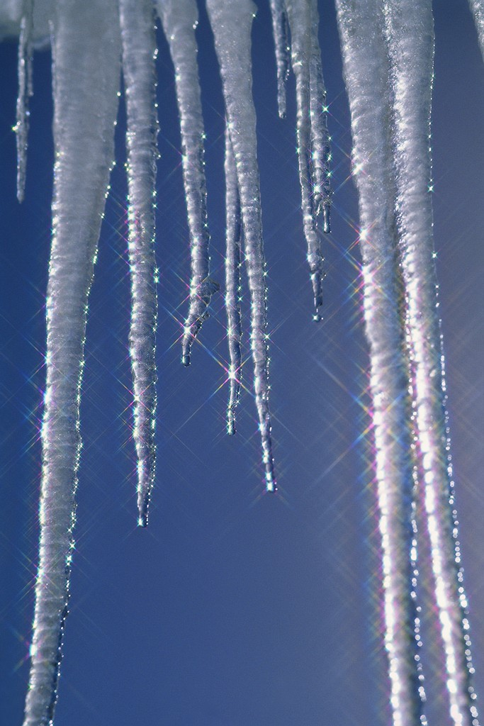
Cold Weather Advice for Schools

Over recent winters we have experienced some harsh conditions, therefore it is important to remember how to protect your staff, property and prevent insurance claims.

The advice in this document has been provided by:
• Risk & Business Continuity
• Insurance
• Health & Safety
• Passenger Transport
• Premises & Planning
• Shire Services
• Property Services Group

Contact details for the above can be found at the end of this document.

Emergency Closures/Snowline
There is in place a procedure to follow should an emergency closure of your school be
necessary due to severe weather. Please see the following area of the Shropshire Learning
Gateway: -

https://www.shropshirelg.net/leadership-management-and-administration/cold-weather-advice/emergency-closure/
Please note, access is restricted to headteacher SLG user accounts (e.g., head@, exechead@)
Salt Supply
This year’s Salt/Grit suppliers are: -
Nurture Group
Robert Barass, Operations Manager
Email: robert.barrass@nurture-group.co.uk

For details of this year's supplier please use the following link: -
2025 -2026 Salt Supply Information
Protecting your Property - Internal and External
Extreme cold conditions can lead to burst pipes and subsequent water damage in
Shropshire Council properties. Although the resulting damage in such cases is covered by
the Council's corporate Property Insurance, the time spent in with the incident, together with any related claim will not be.

A claim for extensive water damage can mean that the repairs and the claim are not
for many months. The simplest solution is to do what you can to prevent an
incident occurring in the first place and also to look for ways to minimise the damage if
something was to happen.

Attached at Appendix A are three checklists to assist you when considering ways to protect
your school and people who use your site:

• heating checklist
• pipework checklist
• site maintenance checklist

Please note these finalised checklists are not exhaustive - they are merely a starting point.

Gritting/Salting
It is a popular misconception that an occupier cannot be held liable for failing to clear
snow/ice, but can be held liable once an attempt at clearance has been made and then
someone injured. The true position is that an occupier can be held liable for 'failing to act
reasonably' in order to prevent accidents.

There are several areas of legislation where it is pointed out a duty of care is owed to the
employees, pupils and visitors (lawful or unlawful) including:

• Health & Safety at Work Act
• Workplace Regulations
• Occupiers Liability Act

It is important that access to school sites and buildings is safe for staff, pupils and visitors
and adequate arrangements are made to ensure risks from snow and ice are minimised. It
is recognised it is not possible to remove immediately every piece of snow and ice - so we must prove whatever we decide to do is reasonable and practicable.
The key to defending slipping on snow/ice claims is to prove that you have a system in
place and that you follow your procedures/policies. The courts would require
documentation to prove the following points before deciding if a school had been negligent:

- a snow/ice/gritting policy in place at the time of the incident
- the policy is reasonable/practicable
- the policy is communicated to staff and other relevant site users
- the procedures set out in the policy were adhered to

Our Health & Safety Team have also advised:

Winter gritting of car parks and paths can be time consuming and a resource issue. This is
where risk assessment comes into place by prioritising action based on the nature,
frequency etc. of the hazards identified. Your risk assessment should consider, main
routes, pathways etc. Control measures should consider communications to members of
staff and to visitors who will come onto the site, limiting access to some areas in severe
weather etc.

Some measures can include: using Met Office data – to anticipate the impact of bad
weather. This means that salting can be done in advance of a bad frost and also you only
salt when you need to – potentially saving time and resource over the course of a winter.

Finally, don’t forget the need to demonstrate that you’ve taken reasonable steps. Bad
weather is above all unpredictable. Even if you very significantly reduce the risks, an accident is still possible. To effectively pre-empt legal challenges and insurance claims,
documenting any action you do take is important.

Headteachers for schools should ensure adequate risk assessments have been carried out
and the control measures identified are in place prior to the winter season.

The control measures may include:
• the adequate provision/storage of de-icing salt as appropriate
• identifying those who would carry out the salting activity
• ensuring adequate training has been provided including manual handling
• producing a gritting plan to prioritise which areas will be treated and brought to the
attention of all those concerned.

There is no simple answer to the gritting questions. Each school will have different needs
and therefore require individual risk assessments.

As a guide to documenting such an assessment use the following link to a ‘gritting in icy
conditions’ generic template which can be used by premises to set out their local
procedures for dealing with such conditions.
Risk Assessment
An example ‘Gritting in Icy Conditions’ risk assessment is available, remember - this document must be personalised to suit the individual school and is a guide
as to the kind of issues that require consideration.

Guidelines for Contractors or staff at primary schools who are responsible for opening the premises are detailed in Appendix C.
Driving in adverse weather conditions
If you are using a vehicle in cold/icy conditions, it is important that you consider the
following:
- Follow national guidance - only set out if your journey is absolutely necessary. Please note that where the local authority has advised schools (based on Government's advice) not to travel, the cancellation cost may be covered by your school’s trip insurance.
- If you must travel, make sure you have certain items in the vehicle, e.g. shovel, de-icer, warm clothing and blankets, food, hot drinks and a fully charged mobile phone.
- Plan additional time for your journey.
- Adapt your driving style to the conditions. Be smooth and gentle with steering and brakes and allow much longer breaking distances than you would normally. Always try and use the highest possible gear to avoid sudden acceleration on icy roads or in snow conditions. Do not attempt to drive through expanses of water.
- When warming your vehicle up - don’t leave it unattended with the keys in the ignition - there is no cover for this on any Motor insurance policy.
- Have your Antifreeze checked in the Autumn to ensure that you avoid engine damage caused by frozen cooling systems, check your car handbook to ensure you use the right type of fluid as there are different types required for certain engines.
- Ensure that windscreens and all windows are defrosted and clear before driving.
- Check that wipers are not frozen to screens and water jets are not frozen before being used. Doing so may blow a fuse or damage the wiper motor and blades. Use ‘All Season’ or ‘Winter Screen wash’.
- For vehicles equipped with Air conditioning or Climate control the quickest way to demist or defrost the vehicle is to put the system on re-circulation, maximum heat and run for 5 minutes.
- If your battery is sluggish in autumn, get it checked as Frosty weather can reduce the battery efficiency by 30%.

Attached at Appendix B is a Vehicle Maintenance to assist you.
School & Public Transport
The Passenger Transport Group explain their procedures during severe weather in their ‘Code of Conduct’ which is available to all parents and students and can be found at www.shropshire.gov.uk/school-transport/your-childs-safety/.
For information relating to public transport operating during extreme weather, it is recommended to contact your local bus operator of a particular service to determine reduced frequencies, diversions or cancellations. Contact details of local bus operators in Shropshire can be found at https://next.shropshire.gov.uk/roads-travel-and-parking/public-transport/travelling-by-bus/bus-operator-contacts/

Code of Conduct and Guidance for Operators, Drivers and Escorts
The Passenger Transport Services' Team have produced the above document, which
provides severe weather guidance.

Please contact the Passenger Transport Services’ Team to obtain a copy of this document.

School Meals (Shire Services)
In the event of severe weather, causing disruption to the school meals service, either by
catering staff not being able to attend work or the school being partly or totally closed. You
should notify the school meals helpline on 01743 250260 or contact the relevant Contract
Manager directly.

If catering staff are unable to attend work, alternative arrangements will be put in place to
ensure that a hot meal is provided for all children attending school that day. Please do not
ask parents to provide a packed lunch unless you have been advised by Shire Services that
it will not be possible to provide a meal.

Any queries about the school meals service please call either your Contract Manager or the
Helpline.

For schools who do not use Shire Services, please contact your individual catering providers for advice in the event of a bad weather incident.

Winter Wellness
There are still measures which can be taken to reduce the risk of catching and spreading Covid-19 and other flu’s;
- Getting vaccinated
- Let fresh air into buildings
- Regular hand washing
- Consider wearing face covering in crowded spaces

Please see gov.uk for updated advice and Self care | Shropshire Council.

Business Continuity
To reduce the impact of adverse weather conditions we recommend you consider taking the
following steps:

- Review your Emergency Response & Business Recovery Plan.
- Think about how you will communicate with your staff in the event of an out-of-hours incident where, for example, you do not want people to attend a site on the following working day.
- Consider how you might deal with staff who become stranded at work.
- Give early warnings of any problems to your customers and suppliers.
- Make sure you have up to date contact details for all staff.
- List the telephone numbers of the people you may need to contact for assistance, e.g. Insurance team, Premises Services etc.
- Make sure that only essential business travel continues between sites.
- Wherever appropriate provide regular updates to staff and any other impacted stakeholders

Make sure you have up-to-date contact details for staff in ERP.
For guidance on how to update/ add details in the ERP, please find details in this link:-
https://staff.shropshire.gov.uk/how-do-i/hrpayroll/how-do-i-check-and-update-my-emergency-contact-details-in-the-erp/

Details on how to do this can be found here:-

Updating Emergency Contact Details in the ERP - YouTube
Contact Information
Risk & Business Continuity Team
(01743) 256481
Saskia.richardson@shropshire.gov.uk

Insurance Team
(01743) 258458
insurance@shropshire.gov.uk

Health & Safety Team
(01743) 252819
health.safety@shropshire.gov.uk

Passenger Transport Team
(01743) 253031
Email: ptscontracts@shropshire.gov.uk

Transport Operations Group
(01743) 254944

Property Services Group
EMERGENCY OUT OF HOURS MOBILE – 07990 087815
Matt Jordan – Facilities & Maintenance Manager – 01743 252668
Rob Woodbury – Major Works Manager – 01743 252734
Phil Brown - Team Leader Minor Works – 01743 281067
Suzanne Claydon - Team Leader Major Works – 01743 281097
Luke Blakeway – Team Leader Technical & Compliance –01743 281093
Nathan Davies – Team Leader Reactive – 01743 254518
Help Desk (repairs) – 01743 281079
Shire Services
(01743) 250250

Shire Services (Helplines)
(01743) 250270 for cleaning
(01743) 250260 for catering

HSE
http://www.hse.gov.uk/slips/faq.htm#icyconditions

Helpful Links for Weather Monitoring
Met Office website - http://www.metoffice.gov.uk
BBC weather website - http://news.bbc.co.uk/weather/forecast/2
Appendix A

Heating Checklist
Monitor Weather Forecasts (see Useful Links for Weather Monitoring) to anticipate cold spells and activate heating protocols early.
Test Heating Systems - confirm boilers, radiators, and thermostats are operational. Arrange servicing if not recently completed.
Ensure adequate stocks of heating oil, wood pellets, or other fuels to last through the holiday period. Reorder early to avoid delays.
Inspect Thermostats and Frost-Stats to verify they are functioning and correctly set to maintain minimum temperatures (e.g. 5°C in unoccupied areas).
Close blinds and tuck curtains behind radiators to retain heat. Avoid blocking radiators with furniture or soft furnishings.
Ensure all radiator valves are turned on and set appropriately. Replace faulty thermostatic radiator valves (TRVs) if needed.
Bleed Radiators - remove trapped air to ensure even heat distribution and prevent cold spots.
Review Heating Timers - Adjust timers to maintain warmth during vulnerable periods, especially overnight and weekends.
Monitor Room Temperatures - use thermometers to confirm that minimum temperatures are being maintained in classrooms and communal areas.
Inspect for Leaks or Cold Spots - Look for signs of damp, condensation, or uneven heating. Address issues promptly.
Ventilation - ensure ventilation systems are not drawing in cold air unnecessarily. Turn off extractor fans in unused areas.
Know Your Stopcocks - ensure staff know where water shut-off valves are located and that they are accessible and functional.
Prepare for Power Failures - review emergency heating arrangements.
Update Risk Assessments - if portable heaters are used, ensure fire risk assessments are updated and staff are trained in safe use.

Burst Pipe Prevention Checklist
Drain down water systems in areas that will be unused for extended periods. For properties unoccupied over 30 days, follow insurer protocols including formal notification and system isolation.
Protect and insulate all exposed pipework, including external walls, roof voids, and basements. Schedule regular inspections for signs of wear or corrosion.
Ensure insulation is intact and seal gaps around windows, doors, and crawl spaces to prevent cold air ingress.
Turn off extractor fans in unused areas and ensure ventilation systems do not draw in cold air near pipework.
Repair dripping taps and faulty washers promptly to prevent freezing and pressure build-up.
Turn off and drain all valves serving external taps. Consider installing frost-proof outdoor taps.
Ensure staff know the location of stop taps and valves. Test them regularly to confirm they are operational.
Store electrical and perishable items off the floor and away from plumbing fixtures to prevent water damage.
Inspect buildings daily during and after freezing conditions. Check for leaks, damp patches, and unusual pipe noises.
Notify Premises Services immediately if water supply freezes. Activate thaw protocols to prevent pipe rupture.
Run taps and flush toilets daily during cold spells to confirm water flow and detect freezing early.
Maintain a minimum temperature (e.g. 5°C) in unoccupied areas to prevent freezing.
Let taps drip slightly during extreme cold to relieve pressure and prevent freezing.
Service boilers and heating systems annually to ensure efficiency and reliability.
Provide training to site staff on early signs of pipe stress and emergency shut-off procedures.
Document and communicate cold weather procedures and burst pipe protocols to all relevant staff.

Site Maintenance Checklist
Regularly check all outdoor lighting for functionality, damage, and cleanliness. Ensure landscaping does not obscure lighting units or cast strong shadows across pedestrian routes. Test emergency lighting as part of routine inspections.
Inspect gutters and downpipes for blockages year-round (including leaves, debris, and moss), not just during winter, to prevent water ingress and structural damage.
Extend roof inspections to include checks for loose flashing, moss growth, and pooling water on flat roofs, in addition to replacing or repairing missing or damaged tiles.
Clear external pavement steps, basement stairwells, drainage gullies, grills, and grates of leaves, snow, ice, mud, and other debris as needed to maintain safe access and reduce slip and trip hazards.
Check all drainage channels and grids for blockages regularly throughout the year to prevent flooding and slip hazards, not just in winter.
Inspect external steps, handrails, and signage for damage or wear to ensure all access routes are safe and clearly marked.
Check emergency exits and fire safety equipment (such as extinguishers and alarms) to ensure compliance and occupant safety.
Document all inspections and maintenance actions, including the date, findings, and actions taken, to provide evidence of compliance and support risk management.

Appendix B
Only travel if your journey is absolutely necessary.
Vehicle Maintenance Checklist
Keep up to date with road conditions, accidents and road closures.
Check tyre, battery and wiper blade condition.
Ensure lights are fully functioning.
Check oil and fuel levels before leaving.
Check anti-freeze levels and carry de-icer in case the locks freeze.
Check your screen washer level – salt spray from the road quickly obscures visibility (carry spare in the vehicle)
Have your breakdown telephone helpline number and mobile phone with you.
If you do have an accident and the vehicle is immobilised use your hazard warning lights to alert other motorists. If you have a hazard warning triangle, place this approximately 45m (around 50 steps) behind the vehicle.
Consider taking a bottle of water and a warm blanket should you become stranded for a period of time. Take or wear appropriate warm clothing and footwear.
Consider Emergency equipment (e.g., high visibility jacket, snow shovel, torch, warning triangle, webbing cutter, First Aid Kit)

Appendix C

Cold Weather Gritting Snow Clearance Advice for the contractor or staff at Primary Schools where persons are responsible for opening the premise

Teams who are responsible for clearing snow or gritting areas need to be aware of the appropriate policies and procedures including risk assessments.

Direction on what is acceptable and what is not may differ at each premise.

Staff must take care of themselves during adverse weather conditions as those with key holder responsibilities will be first on site.

It is important that staff have easy access to the equipment needed to clear/ grit access and egress areas.

There will be restrictions at some sites as it would be impractical to clear / grit all pathways. You will need to discuss this with the Headteacher or nominated person on site.

Each site will have an agreement as to which areas will be cleared and this must be communicated to all premise staff and visitors.

Process:

- Check that premise heating systems are operational.
- Collect equipment for snow and ice clearance.
- Observe manual handling risk assessment – do not lift or transport items that are too heavy.
- Larger areas require a suitable grit spreader to combat ice and snow on access ways. Always clear snow first and then grit the area.
- To move snow use a suitable clearance shovel – this should be lightweight. Move snow out of pathways, do not lift.
- Once snow is cleared, grit the area using a suitable spreader.
- For small areas a reduced quantity of grit in a container can be used. Keep the content to a minimum to avoid injury. Do not twist or over stretch when spreading grit. Always follow Manual Handling procedures and the Gritting Risk Assessments

Do not put yourself at risk, keep yourself safe at all times and follow policy and procedures and the gritting process agreed for your site.

Should you have any queries please contact either your Contract Manager or the Head Teacher, further advice can be sought by contacting the Health & Safety Team (01743) 252819 or by emailing health.safety@shropshire.gov.uk

