
DSE Workstation Checklist

Workstation location: |  | Computer No.
User:

Tel. number:
Email address:
Checklist completed by:
Date of assessment:
Line Manager Name:

Line Manager Signature:

Any further action needed? | YES |  | NO
Follow up action completed on:

The following checklist can be used to help you complete a risk assessment to comply with the Health and Safety (Display Screen Equipment) Regulations 1992, as amended 2002. It is intended for Users who do not have access to the online Cardinus Display Screen Equipment Healthy Working training and assessment programme.

Before completing this checklist users should complete the Display Screen Equipment course on Leap into Learning.

The User should work through the checklist, entering either ‘Yes’ or ‘No’ against each risk factor:
■ If the answer in the second column is ‘Yes’, having taken account of the ‘Things to consider’, the DSE setup is complying. No further action is required.

■ ‘No’ answers will require investigation and/or remedial action. The User and Line Manager should then discuss what ‘Action to take’ and record it in the fourth column.
The Line Manager should check periodically to ensure progress has been made to complete these actions. Completion should be recorded in column five.

The completed checklist should be saved locally and retained on file, for 4 years, in line with the Council’s Document Retention Schedule.

Note: the checklist only covers the workstation and work environment. You also need to make sure that the work is organised so that a change of activity or time to take breaks away from DSE are allowed.

Risk Factors | Yes/No | Things to consider | Action to take | Date action complete
1 Keyboards
Is the keyboard separate from the screen? |  | This is a requirement, unless the task makes it impracticable (e.g. where there is a need to use a portable).
Does the keyboard tilt? |  | Tilt need not be built in.
Is it possible to find a comfortable keying position?  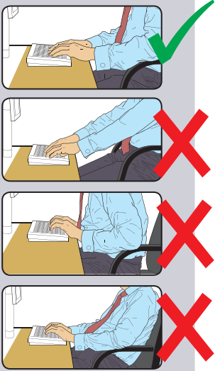 |  | Try pushing the display screen further back to create more room for the keyboard, hands and wrists.  Users of thick, raised keyboards may need a wrist rest.
Does the user have good keyboard technique? |  | Training can be used to prevent:  - hands bent up at wrist;  - hitting the keys too hard;  - overstretching the fingers.
Are the characters on the keys easily readable? |  | Keyboards should be kept clean. If characters still can’t be read, the keyboard may need modifying or replacing.  Use a keyboard with a matt finish to reduce glare and/or reflection.
Risk Factors | Yes/No | Things to consider | Action to take | Date action complete
2 Mouse, trackball etc.

Is the device suitable for the tasks it is used for? |  | If the user is having problems, try a different device. The mouse and trackball are general-purpose devices suitable for many tasks, and available in a variety of shapes and sizes. Alternative devices such as touchscreens may be better for some tasks (but can be worse for others).
Is the device positioned close to the user?  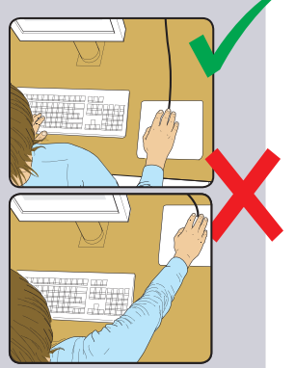 |  | Most devices are best placed as close as possible, e.g. right beside the keyboard.  Training may be needed to:  - prevent arm overreaching;  - tell users not to leave their hand on the device when it is not being used;  - encourage a relaxed arm and straight wrist.
Is there support for the device user’s wrist and forearm? |  | Support can be gained from, for example, the desk surface or arm of a chair. If not, a separate supporting device may help.  The user should be able to find a comfortable working position with the device.
Does the device work smoothly at a speed that suits the user? |  | See if cleaning is required (e.g. of mouse ball and rollers).  Check the work surface is suitable. A mouse mat may be needed.
Can the user easily adjust software settings for speed and accuracy of pointer? |  | Users may need training in how to adjust device settings.
Risk Factors | Yes/No | Things to consider | Action to Take | Date action complete
3 Display Screens

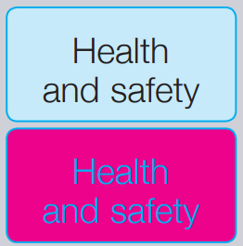  Are the characters clear and readable? |  | Make sure the screen is clean and cleaning materials are made available.  Check that text and background colours work well together.
Is the text size comfortable to read? |  | Software settings may need adjusting to change text size.
Is the image stable, i.e. free of flicker and jitter? |  | Try using different screen colours to reduce flicker, e.g. darker background and lighter text.  If problems still exist, get the set-up checked, e.g. by the equipment supplier.
Is the screen’s specification suitable for its intended use? |  | For example, intensive graphic work or work requiring fine attention to small details may require large display screens.
Are the brightness and/or contrast adjustable? |  | Separate adjustment controls are not essential, provided the user can read the screen easily at all times.
Does the screen swivel and tilt? |  | Swivel and tilt need not be built in; you can add a swivel and tilt mechanism.  However, you may need to replace the screen if:  - swivel/tilt is absent or unsatisfactory;  - Work is intensive; and/or  - the user has problems getting the screen to a comfortable position.
Is the screen height adjustable?  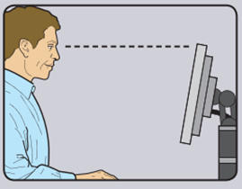 |  | The top of the screen should ideally be at eye level. If the screen height is not adjustable then a monitor riser or adjustable monitor stand can be used.
Is the screen free from glare and reflections?  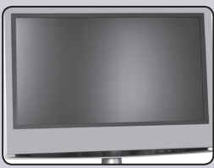 |  | Use a mirror placed in front of the screen to check where reflections are coming from.  You might need to move the screen or even the desk and/or shield the screen from the source of reflections.  Screens that use dark characters on a light background are less prone to glare and reflections.
Are adjustable window coverings provided and in adequate condition? |  | Check that blinds work. Blinds with vertical slats can be more suitable than horizontal ones.  If these measures do not work, consider anti-glare screen filters as a last resort and seek specialist help.
Risk Factors | Yes/No | Things to consider | Action to Take | Date action complete
4 Software
Is the software suitable for the task? |  | Software should help the user carry out the task, minimise stress and be user-friendly.  Check users have had appropriate training in using the software.  Software should respond quickly and clearly to user input, with adequate feedback, such as clear helpful messages.
Risk Factors | Yes/No | Things to consider | Action to Take | Date action complete
5 Furniture

Is the work surface large enough for all the necessary equipment, papers etc?  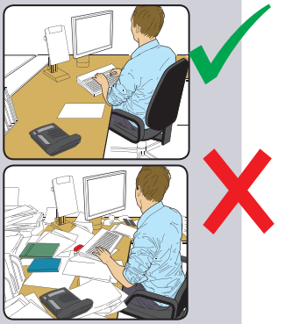 |  | Create more room by moving printers, reference materials etc. elsewhere.  If necessary, consider providing new power and telecoms sockets, so equipment can be moved.  There should be some scope for flexible rearrangement.
Can the user comfortably reach all the equipment and papers they need to use? |  | Rearrange equipment, papers etc. to bring frequently used things within easy reach.  A document holder may be needed, positioned to minimise uncomfortable head and eye movements.
Are surfaces free from glare and reflection? |  | Consider mats or blotters to reduce reflections and glare.
Is the chair suitable?  Is the chair stable?  Does the chair have a working:  - seat back height and tilt adjustment?  - seat height adjustment?  - swivel mechanism?  - castors or glides? |  | The chair may need repairing or replacing if the user is uncomfortable or cannot use the adjustment mechanisms.
Is the chair adjusted correctly?  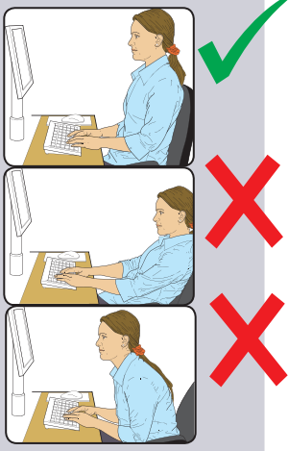 |  | The user should be able to carry out their work sitting comfortably.  Consider training the user in how to adopt suitable postures while working.  The arms of chairs can stop the user getting close enough to use the equipment comfortably.  Move any obstructions from under the desk.
Is the small of the back supported by the chair’s backrest? |  | The user should have a straight back, supported by the chair, with relaxed shoulders.
Are forearms horizontal and eyes at roughly the same height as the top of the DSE? |  | Adjust the chair height to get the user’s arms in the right position, and then adjust the DSE height, if necessary.
Are feet flat on the floor, without too much pressure from the seat on the backs of the legs? |  | If not, a footrest may be needed.
Risk Factors | Yes/No | Things to consider | Action to Take | Date action complete
6 Laptop users only (prolonged use)

  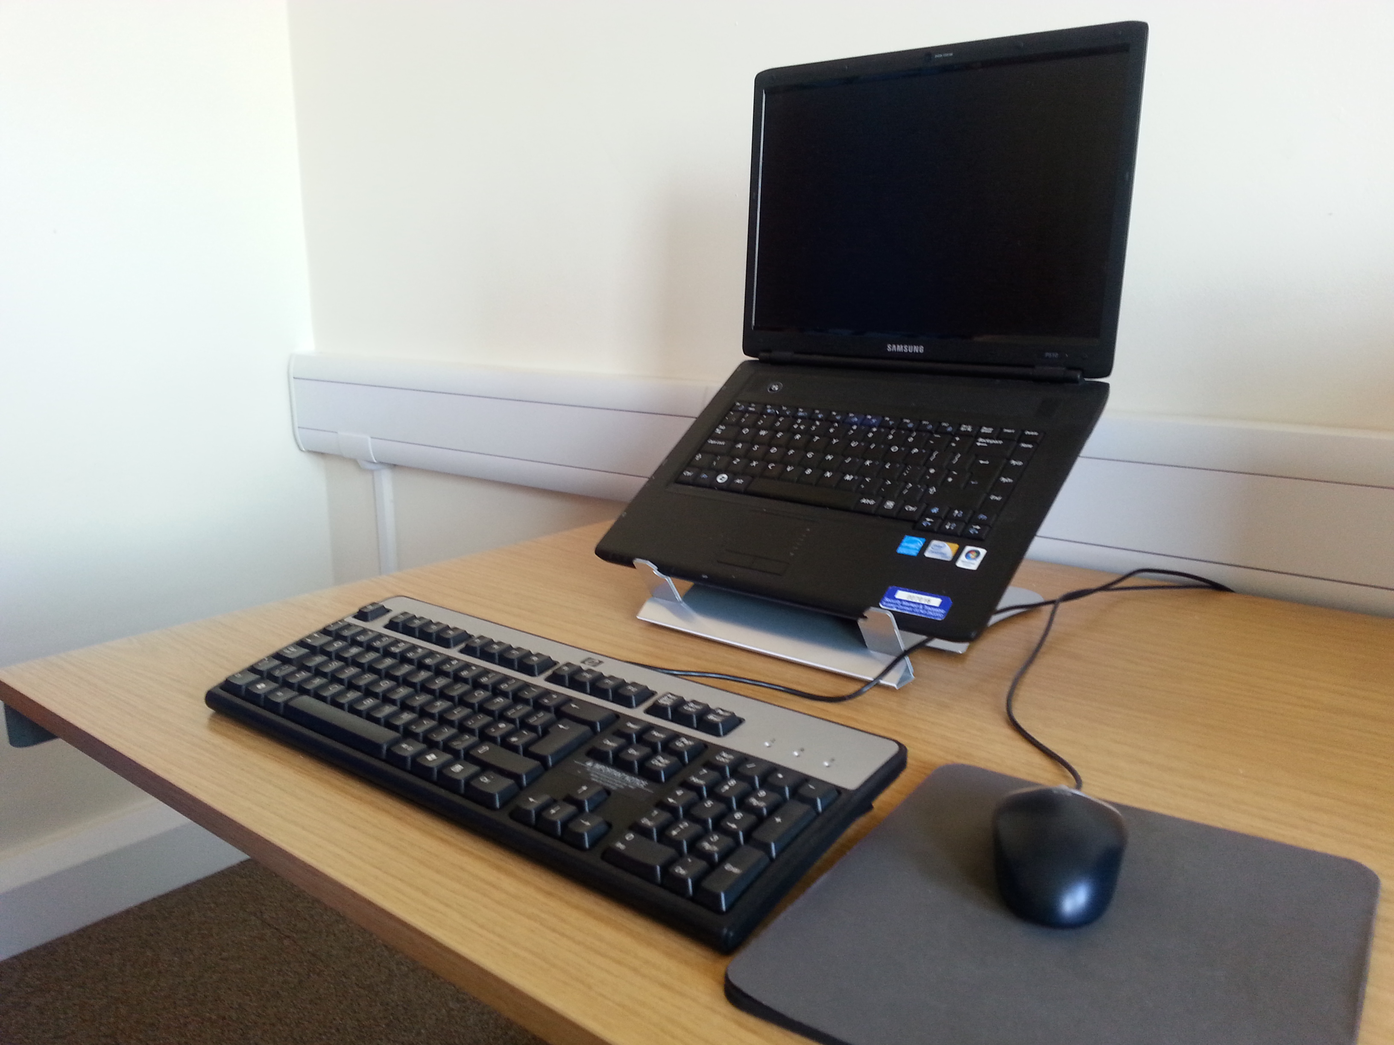Do you have a laptop riser, or a docking station and monitor? |  | Portable computers must not be used for prolonged periods at the employee’s workplace without the use of a riser or docking station and separate monitor. Docking stations are a way to avoid many of the ergonomic disadvantages of using laptops by allowing for the use of a full-sized screen, keyboard and mouse.  Because it is harder to find a good posture to use these devices, the risk to the user of discomfort and fatigue is increased and needs to be managed.  Portable DSE is only exempt from the regulations if it is not in prolonged use.
Do you use a separate keyboard and mouse? |  | Portable computers must not be used for prolonged periods at the employee’s workplace without the use of a separate keyboard and mouse.
Risk Factors | Yes/No | Things to consider | Action to Take | Date action complete
7 Sit/Stand desk (If applicable)

Does the desk allow for all the correct postures as outlined in above risk factors? |  | Consider above risk factors when setting up a sit/stand desk e.g. screen height, keyboard and mouse use, space to move.
When standing can the desk be elevated enough to ensure the forearms remain horizontal when the hands are on the keyboard?

Does the desk allow for frequent change from sitting to standing and back again? |  | Consider a 20:20 regimen – or sitting (in a good posture) for 20 minutes, standing for 20 minutes. Going from sitting to standing and vice versa frequently throughout the day may help with risk factors associated with sitting, or indeed with standing for long periods
Risk Factors | Yes/No | Things to consider | Action to Take | Date action complete
9 Environment

Is there enough room to change position and vary movement? |  | Space is needed to move, stretch and fidget.  Consider reorganising the office layout and check for obstructions.  Cables should be tidy and not a trip or snag hazard.
Is the lighting suitable, e.g. not too bright or too dim to work comfortably? |  | Users should be able to control light levels, e.g. by adjusting window blinds or light switches.  Consider shading or repositioning light sources or providing local lighting, e.g. desk lamps (but make sure lights don’t cause glare by reflecting off walls or other surfaces).
Does the air feel comfortable? |  | DSE and other equipment may dry the air.  Circulate fresh air if possible. Plants may help.  Consider a humidifier if discomfort is severe.
Are levels of heat comfortable? |  | Can heating be better controlled?  More ventilation or air-conditioning may be required if there is a lot of electronic equipment in the room.  Or can users be moved away from the heat source?
Are levels of noise comfortable? |  | Consider moving sources of noise, e.g. printers, away from the user. If not, consider soundproofing.
10 Final questions to users

Ask if the checklist has covered all the problems they may have experienced whilst working with their DSE?

Ask if they have experienced any discomfort or other symptoms, which they attribute to working with their DSE?

Ask if the user has been advised of their entitlement to eye and eyesight testing?

Ask if the user takes regular breaks working away from DSE?

Write the details of any problems here:

