How do I view open invoices in the system? – P2P Invoice Status Enquiry

To view the image and status of your open invoice in Unit4 Business World, once you log into the system you can go to Reports > P2P > P2P – Invoice Status Enquiry

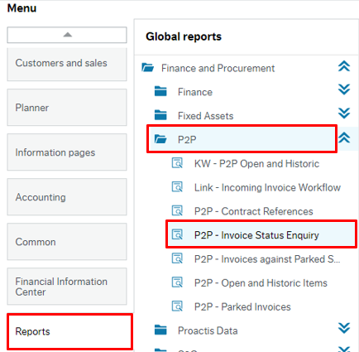

This will direct you to an enquiry page in the system and you will then have a range of options by which you can search for your invoice.
In the example below the invoice number has been input and then click on the search button and all of the possible results have been returned. You could also search by Supplier ID, Supplier Name, transaction number, your Cost Centre or Account Code (subjective) if required.

N.B. If you need to look up Supplier ID, this can be done under Procurement > Supplier information > Suppliers. In the Lookup box, type ahead can be used to type the supplier name to identify the supplier ID.

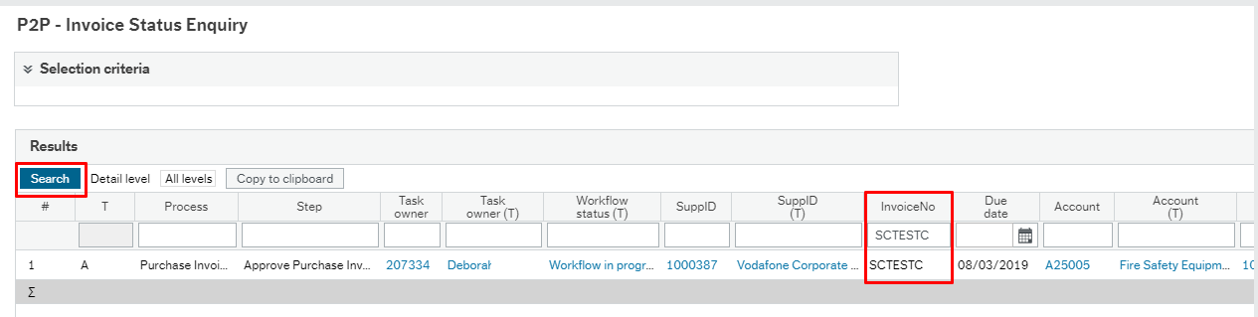
How do I view the Invoice Image?
You can scroll on the page and then click on the transaction number of the invoice which is highlighted in blue
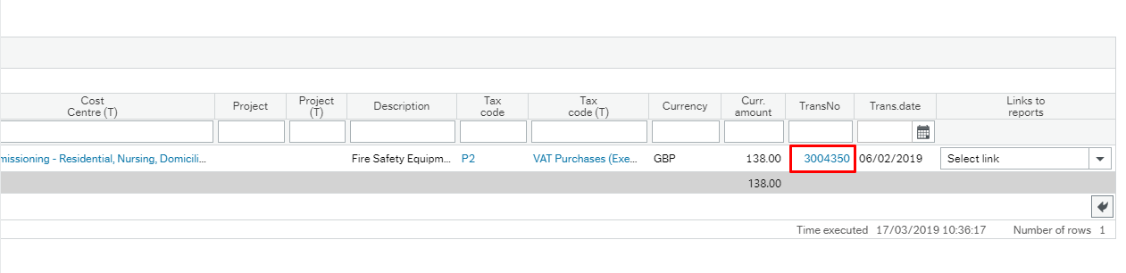

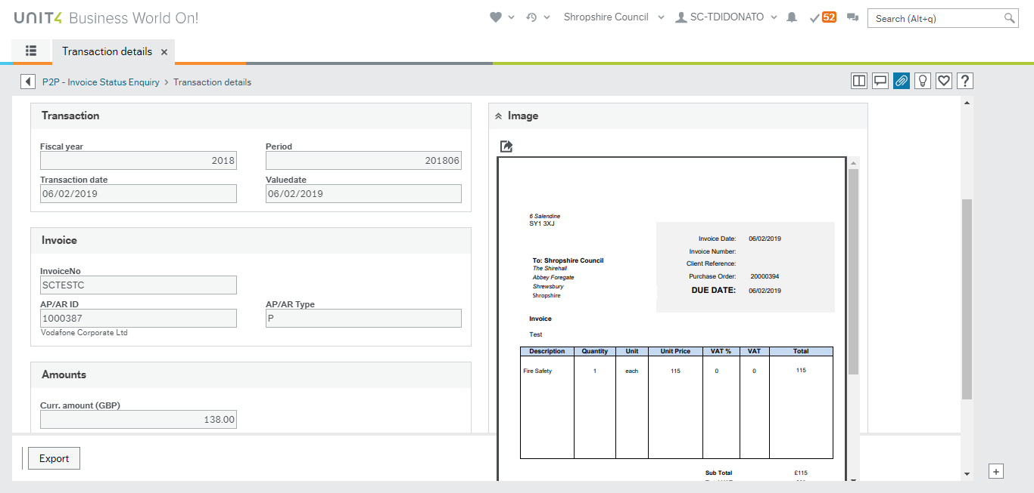

How do I know the status of the Invoice from this enquiry?
The key to understanding the status of your invoice is shown in the T column on the enquiry page.
If the Status is A – This means that the invoice is in workflow and requires further action before it will be paid.
If the Status is B – This means the invoice is finished in workflow and is either ready for payment or has been paid (N.B. invoices that have been paid (C – Paid), will still appear as status B, you will need to look under Open & Historic items to check payment – see section below.
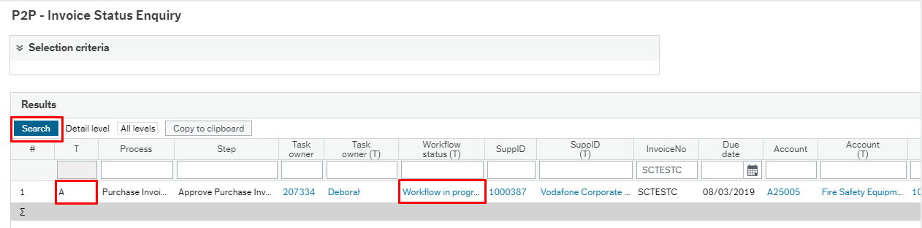
In the example above, because the Status is A, you can click on the ‘Workflow in Progress’ section and this will display a workflow map and show you who the invoice is with to complete further action.

After reviewing the workflow map, you will then be able to liaise with the person that the invoice is with and ask them to take appropriate action to get the invoice paid.

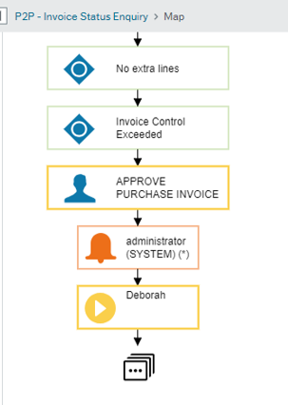

If the Invoice shows as a B status, you can scroll to the right of the screen and on the Link to reports section you can then click on the drop down and the click on Open and Historic.

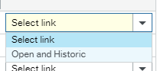

This will then direct you to the payments page and you will be able to see the due date on the invoice and whether the invoice has been paid or not. If the invoice has been paid it will show as a C status.

P2P Open and Historic Items Report
If you have linked to the Open and Historic report through the Invoice Status Enquiry this will take you specifically to the one transaction line for you to view.
If, however, you select Open and Historic Items from the menu you will be able to see all invoice details.
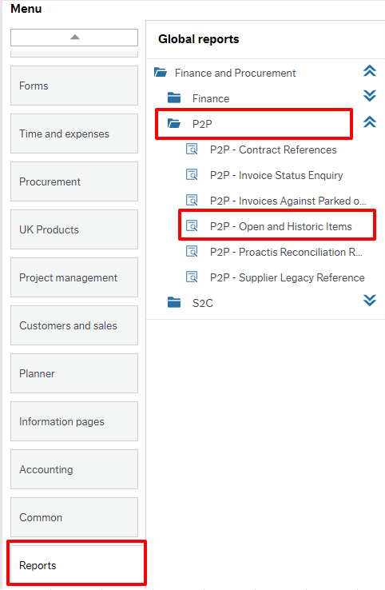

When you open this report you can search a range of items such as Supplier ID, Invoice Number, Transaction Number, Amount.
In the example below the Supplier ID of 1001604 has been typed in.
-For any transactions that show as an A in the T column, this means they are still in workflow and the Invoice Status Report is best to show you exactly what stage these invoices are at.
-For any transactions that show as a B status in the T column, this means they are ready to be paid and will be picked up on the payment run based on it invoice due date.
-For any transactions that show as a C status in the T column, this means have been picked up in the payment run and you will see the Pay Date present in the Pay Date Column. To note this pay date reflects the date that the transaction was picked up in the payment run and so the supplier will receive payment on the 3rd working day from the date showing. For example, if an invoice was picked up in a payment run today with 16th May, the Supplier would receive payment on Monday 20th as the 16th would be the 1st day, 17th the 2nd day and 20th the 3rd working day.
