We are looking for people to become school governors.
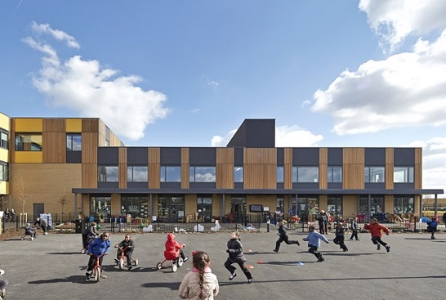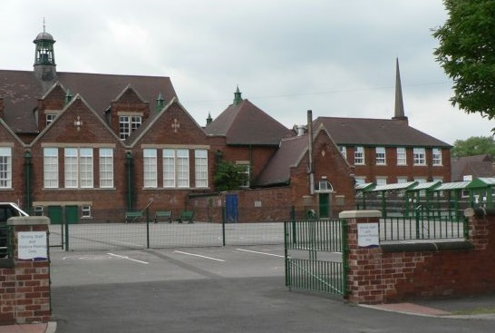

Have you an interest in education?
Do you want to help provide the very best education and care for children and young people?

School governors are volunteers who work together as a governing board. They have a single aim which is to harness their skills and abilities in a planned, determined manner to enable ‘school improvement’.
Governors are people from all walks of life who commit to approximately 2 meetings per term and occasional events. You can become a governor if you have:
• an interest in education;
• time, energy and enthusiasm;
• common sense;
• a willingness to accept responsibility and learn;
• the ability to work and contribute in a team.
NO prior knowledge is necessary as a comprehensive range of training and support is provided.
This is an opportunity to harness your skills and acquire new ones whilst making a real difference to the lives of children and young people.
For further information on current vacancies at our school please contact:
Tel:
Email:


